
How to Treat and Prevent Ingrown Toenails
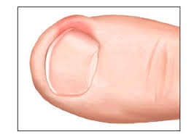
Ingrown toenails are a common problem in teens and adults. Generally they occur when the nail gets cut too short around the edges. This can happen by trimming the nail in a “rounded” fashion or sometimes when you stub your toe and the nail chips off. Whichever the cause, the front edge of the nail becomes too short and then burrows down under the skin on either side of the nail. When this happens, people often will trim the nail that is digging into the skin even shorter. This briefly helps but eventually only makes the problem worse.
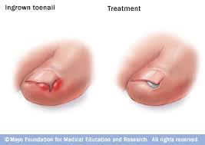
Fixing the ingrown nail involves soaking in warm water and Epsom salts a few times a day. After soaking for 10-15 minutes, the skin and nails will soften. When this happens, gently peel back the overgrown skin and lift the corner of the nail up. Using a pair of tweezers or a manicure scissors, gently tuck a small wad of cotton ball under the corner of the nail to hold it up. The first few times you do this, it might hurt a bit. But with the nail no longer digging into the skin, the pain will quickly subside. Don’t try to pull the skin out all of the way the first time. It will take a few soaks to get there but it will get better. Each time, leave the cotton wad tucked under the nail until the next time you soak. Then take the old piece out, lift the nail a bit further out from under the skin and put in a new piece of cotton. In this way you will quickly “train” the nail to grow how it is supposed to.
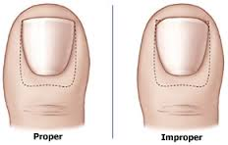
In addition to the soaks, sometimes an antibiotic is prescribed, either a topical ointment or an oral medication. You should use this as prescribed for the whole course. If things aren’t starting to get better after 2-3 days of soaking and “lifting the nail” then call the office. A referral to a podiatrist is occasionally needed to remove part of the nail. In general, I find that if patients follow these directions, that the referral and nail removal can be avoided.
To prevent ingrown toenails from occurring in the future, proper trimming of the nail is vital. Nails should not be cut so that the edges are rounded on the side. The nail needs to be left long enough on the edges so that the nail sticks out beyond the skin. This may cause the occasional snag on the sock, but it will prevent a lot of pain and a trip to see me.
--Be Well
Drew Nash, MD

